V47 Kick off

### **1. Meet the team**

Short individual intro round: background, personal goals, experience in past voyages, learning wishlist

### **2. Common Goals**

What is our goal for the voyage? What does success look like for you and the team?

### **3. Agile Framework in Chingu**

Roles ([Voyage Team Roles](https://youtu.be/f_TzehtBliE) video)

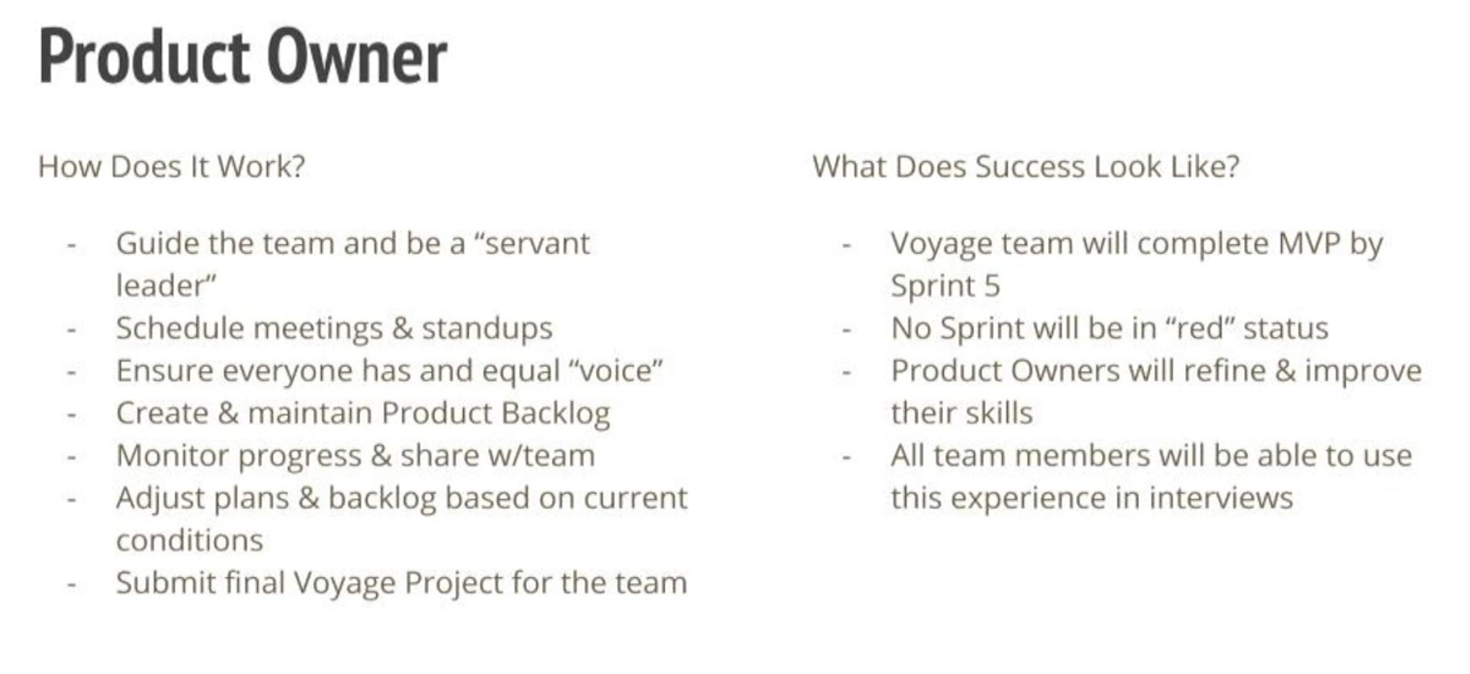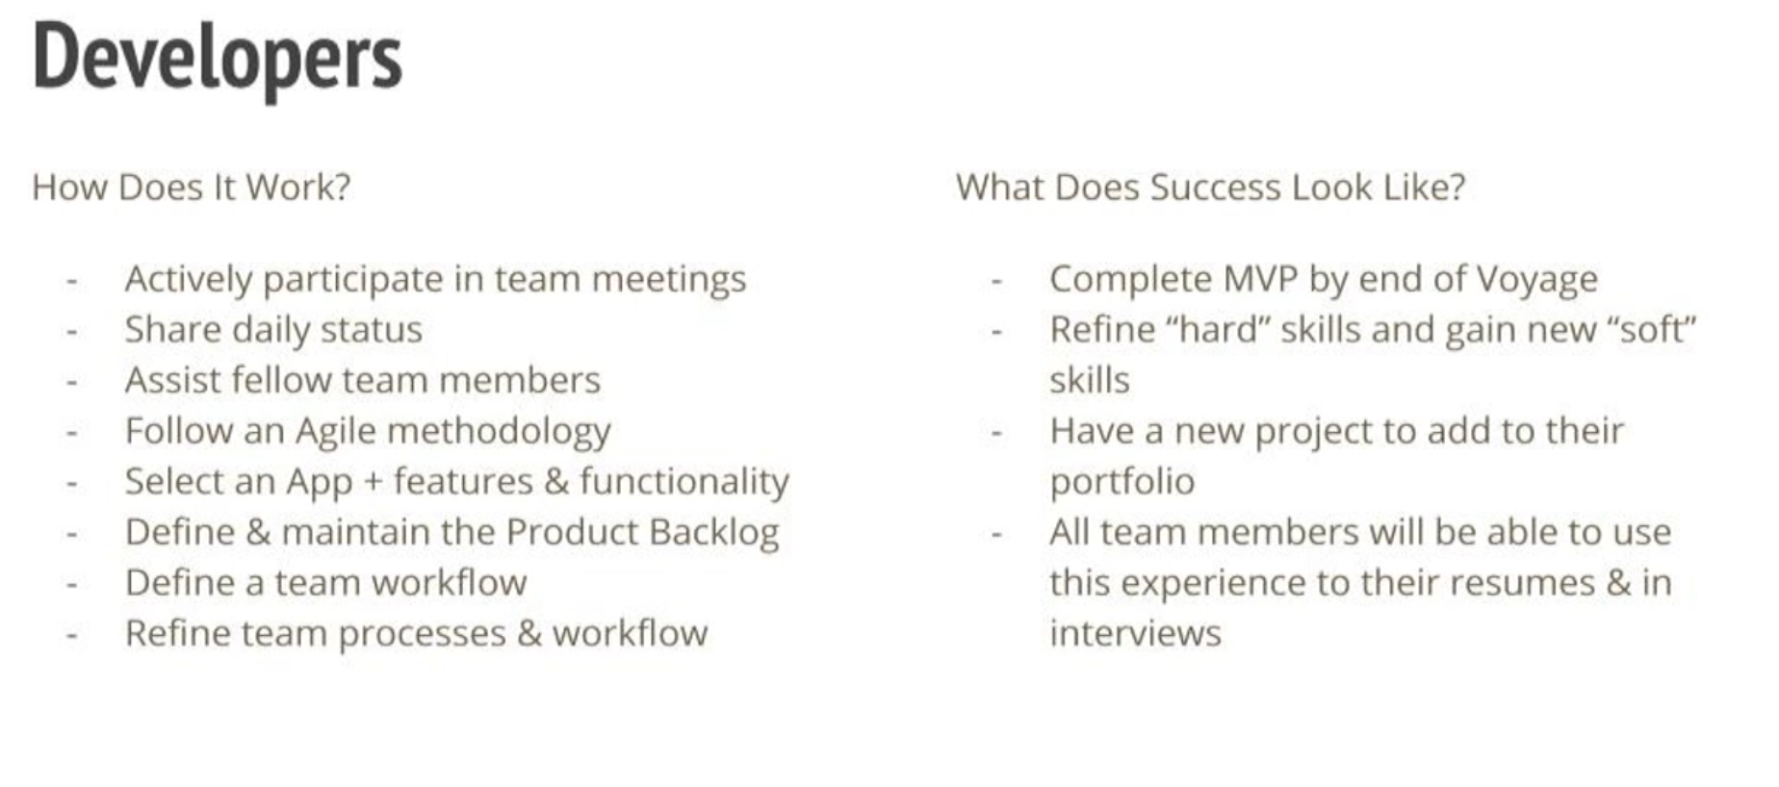

Voyage Overview (on [Voyage Guide](https://github.com/chingu-voyages/Handbook/blob/main/docs/guides/voyage/voyage.md))

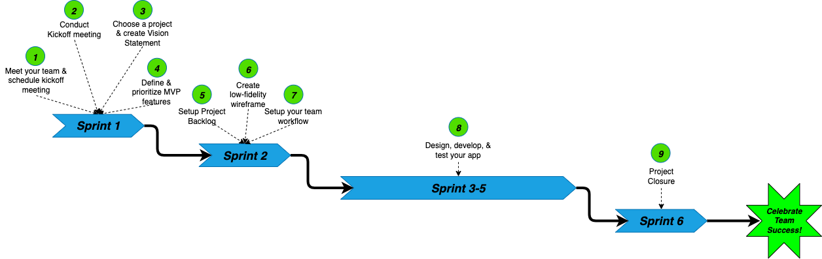

Next meet: Define and Prioritise MVP (see [Project Requirements](https://github.com/chingu-voyages/voyage-project-tier2-dailytasks/blob/main/README.md))

see instructions step 4 on [Voyage Guide](https://github.com/chingu-voyages/Handbook/blob/main/docs/guides/voyage/voyage.md)

### **4. Meeting planning and availabilities**

* Identify everyone's working hours & average time available each week
* Identify what weekly meetings are needed and their time each week
  + Daily standups - TBD
  + Sprint Planning - TBD
  + Sprint Review/Retrospective - TBD
  + Open topic session
* Preferred Tools - also for project management
* Review [GitHub Repo](https://ilanokno.atlassian.net/wiki/pages/resumedraft.action?draftId=1310738&draftShareId=0839ed85-bd51-4b01-a10b-934cb38e9f87)
  + Github Projects will be used for Backlog & Issue Tracking 
    - Project board (TBD)

### **5. Further notes**

* Post your status daily in team channel
  + How am I feeling today? Use an emoji of your choice
  + What have I completed?
  + What am I working on/working on next?
  + Are there any issues I need help with?
* All team decisions will be added to the Team Decision Log [(link)](https://github.com/chingu-voyages/v47-tier2-team-13/blob/main/docs/team_decision_log.md)
* Any questions? Concerns over planning? Thoughts on the project?

### :notepad_spiral: **NOTES**

The timeline for current and future sprints was discussed.

We have limited time for the development and we have to avoid endless feedback: we need to focus on the most important features first and deliver a functional product from the first sprint.

A product vision and goal will be discussed in our next meeting.

### :point_right: **ACTION ITEMS**

1. Daily standups as message in the morning between 7 to 10 (your local time): a message including:
   * What have I completed?
   * What am I working on/working on next?
   * Are there any issues I need help with?
   * How am I feeling today? Use an emoji of your choice
2. Each member will fill up the [‘feature planning’](https://github.com/chingu-voyages/v47-tier2-team-13/blob/main/docs/meeting-vision_and_feature_planning.docx) form and we will find our common high level features and discuss prioritisation in our dedicated meeting on 11/01/2024
3. We will do a weekly video standup in addition to our Scrum ceremonies (Daily, Sprint Planning, Reviews and Retro).
4. Additional voices meet for questions/ support, as needed.